***Evaluating the Effects of Socio-Economic Status on Student Enrollment in Four-Year Colleges Across Texas***

Sanaa Rafique

*May 10, 2019*

*Introduction*

Student enrollment in postsecondary education institutions has known to be widely impacted by the students’ income levels. A large number of academic studies and research is dedicated to understanding exactly how this relationship plays out and some of the measures that can be taken in order to reduce the educational gap between low-income and high-income students. At the same time, there is a visible lack of literature focused on studying the geography of a postsecondary education institution’s location. In particular, the local socio-economic indicators that might influence student enrolled in a college within a region. My paper attempts to add to the current literature by studying the effects of poverty rates of surrounding zip codes of four-year public and private colleges in Texas and student enrollment by race.

*Research Question*

***Examining the relationship between poverty rates of surrounding zip codes of four-year public and private colleges in Texas and student enrollment by race.***

*Literature Review*

A large number of academic studies have researched and found a significant association between poverty and student academic achievement in primary, secondary and postsecondary education.[1] For instance, Diaz documents 4th and 7th grade students’ socioeconomic status as a predictor of their results on the 2003 Washington Assessment of Student Learning scores in Reading and Mathematics. Lacour and Tissington echo the same results in their research paper. They state that poverty significantly affects student achievement “…due to the lack of resources available for student success.”[2] A 2005 meta-analysis study reviewed the literature on socio-economic status and student academic achievement published between 1990 and 2000. “The sample included 101,157 students, 6,871 schools, and 128 school districts gathered from 74 independent samples. The results showed a medium to strong SES–achievement relation.”[3] It is important to not, however, that the relationship between these variables depends upon the school level, minority status, and the location of the school. Another research article pulls together prior research on poverty and its relationship with student academic outcomes and reiterates the well-known fact that “…economic disadvantage can depress students’ academic achievement…”[4]

A research study focused on which school-level characteristics play an important role in student success. The study used cross-sectional data, including the percentage of students who were eligible for free and reduced lunch which primarily gives an indication of the poverty level among students, from the 2013 academic year for 495 public schools in the Chicago Public School district.[5] Affirming existing research on the topic, the study found that poverty has a significant negative impact on students’ test scores.[6] Poverty continues to affect low-income students and impacts their academic outcomes in college. A 2008 research paper found that low-income students a selected colleges across the nation, achieved lower college grade point averages and were less likely to graduate within 6 years from the same institution as compared to their peers.[7] The author believes this gap primarily stems from the gap between “…median SAT scores at the institution they attend.” According to The Pell Institute, around 4.5 million low-income and first-generation students across the nation have to path an uncertain and difficult path to college graduation.[8] The study used data from the National Center for Education Statistics’ Beginning Postsecondary Study (BPS: 96/01)[9] and “…found that low-income, first-generation students experience less success than their peers right from the start” This study further documented the impact on low-income and first generation students across varying types of institutions and stated that these groups of students were nearly four times more likely to drop out of college after their first year than other students.

At the same time, income levels have also been known to significantly impact college enrollment. Researchers from the University of Wisconsin-Madison note that “…access to higher education in the United States has become more stratified in recent decades, with a growing concentration of wealthy students attending the most selective of colleges and access to the best institutions of higher learning increasingly constrained for low-income college hopefuls.”[10] In *Improving College Access and Completion for Low-Income and First-Generation Students: The Role of College Access and Success Programs*, Perna writes that in 2012, “…college enrollment rates were about 30 percentage points lower for high school graduates from the lowest family income quintile than from the highest.”[11] Another research paper builds upon current literature and states that despite college enrollment among low-income students increasing significantly over the past decade, “…the share of students from the lowest-income families that enroll in college continues to lag considerably behind college entry rates among the highest income students.”[12]

Despite the vast literature available on the impact of socio-economic status on student achievement and college enrollment, limited studies have focused on how poverty and socio-economic indicators of a geographic area affect college enrollment. A 2016 study discusses the importance of understanding the geographic location of colleges as it “…one of the most basic and obvious dimensions of opportunity, yet policymakers and researchers often overlook how place shapes students’ educational destinations.”[13] The study found that communities with large White and Asian populations had a greater access to college opportunities nearby while those with large Hispanic populations and low educational attainment had the fewest educational opportunities in proximity. My research particularly focuses upon the socio-economic indicators of a college’s location, in particular exploring how the poverty rates of a zip codes surrounding a college affect student enrollment at the college.

*Data Sources and Validation*

For my research, I used data from the U.S Census Bureau, in particular the American Community Survey 2012-2017 and the Integrated Postsecondary Education Data System (IPEDS) Survey 2012-2017. In order to make a more contextual case for my research, I only looked at student enrollment data from four-year public and private colleges in Texas.

Since my research uses data from a foundational data source like the American Community Survey from the U.S. Census Bureau, it is very difficult to validate the figures obtained for poverty rates and population sizes of zip codes in Texas. The American Community Survey because of its large sample size is most preferred for subnational (including zip code-level) data on income and poverty by detailed demographic characteristics. A validation check that might be put in place to authenticate student enrollment by race is for an institution itself to create an account on National Student Clearinghouse’s, a nonprofit organization website. The organization runs a program, StudentTracker, which is the only nationwide source of college enrollment and degree data. More than 3,600 colleges and universities — enrolling over 99 percent of all students in public and private U.S. institutions — regularly provide enrollment and graduation data to the Clearinghouse. This information can be accessed to conduct different types of research analyses for educational purposes.

*Methodology*

For my research, my methodology is divided into two main components, data preparation and data analysis.

Data preparation

Initially, I downloaded the information about poverty rates and populations for all zip codes in Texas between 2012 and 2017 from the U.S. Census Bureau website. Afterwards, I downloaded the names, geographic coordinates and student enrollment percentages for White, Black, Hispanic, and Asian students at four-year public and private colleges in Texas. To further prepare my data for analysis, I calculated the average enrollment of White, Black, Hispanic, and Asian students in Texas colleges between 2012 and 2017.

Data Analysis

I primarily used Python for analyzing my data and generating results. After the data preparation stage, I imported my data files into Python. Then, I called the “*uszipcode*” programmable database which includes up-to-date census and geometry information, specifically the latitudes and longitudes of zip codes within the U.S. Then, I created a loop to generate a list of zip codes which fell within 6 miles of a college’s location in Texas. I chose 6 miles as my benchmark since enrolled college students generally do not live in the zip code of the college and at times, the college might even occupy an entire zip code. After attaining this list of zip codes, I created another loop to generate the average poverty rates weighted by population of the zip codes. I weighted the poverty rates by population size since, some zip codes may have very few residents while some may have thousands of people living in the area. Afterwards, I merged the student enrollment data with the data frame containing the average poverty rate weighted by population size The merged data frame was then used to run OLS regressions for four dependent variables; average enrollment for White students from 2012 to 2017, average enrollment for Black students from 2012 to 2017, averageenrollment for Hispanic students from 2012 to 2017, and average enrollment for Asian students from 2012 to 2017.

*Results*

An Ordinary Least Squares (OLS) regression was run for each of the four dependent variables against the common independent variable, average poverty rate weighted by population size of zip codes within 6 miles of the college’s location. As observed from Figures 1, 2, 3, and 4, the independent variable is statistically significant with all four dependent variables, i.e. average enrollment all four student populations. The coefficient for White students, as shown by Figure 1, appears to be most negatively associated with the independent variable. An interpretation of this result is that as the poverty rates of zip codes near a Texas college increase, the percentage of White students enrolled at the college decreases considerably. On the other hand, as the poverty rates of zip codes near a Texas college increase, the percentage of Asian students enrolled at the college decreases modestly when compared to enrolled Black, White, and Hispanic students.

**Figure 1 Figure 2**

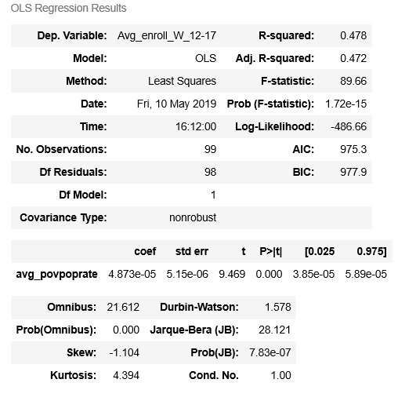

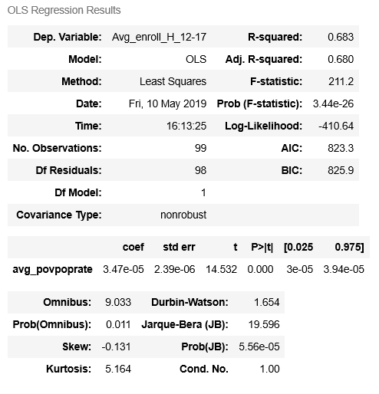

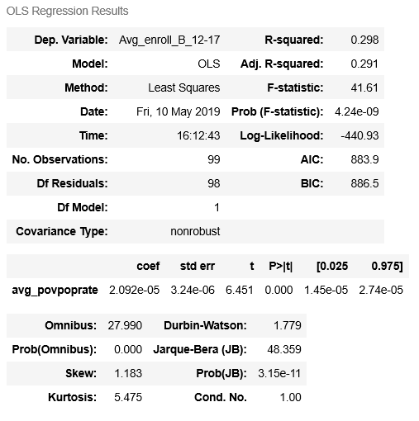**Figure 3 Figure 4**

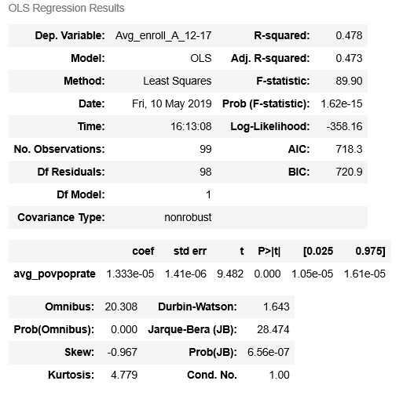

This study has a number of limitations which might affect the accuracy of the results discussed earlier. The data obtained from the Census Bureau had several missing values for poverty rates and student enrollment by race. These missing values, thus, were not taken into account by the OLS regression. Additionally, I only used student enrollment data for four main populations, Whites, Blacks, Hispanics, and Asians. This was done so because the number of enrolled students for other groups of students was extremely low. One of the main limitations of my research is that there is very limited existing literature on my variables of interest. This lack of theoretical knowledge limits my ability to borrow from methodologies of existing research on the subject. Lastly, my results are not meant to determine causality any means rather just present an association between the independent and dependent variables. This is primarily because there might be several other covariates which are not adjusted for in this model, for instance enrolled students’ place of origin and their college readiness.

*Conclusion*

This results of this research show that student college enrollment is strongly negatively associated with poverty rates of the surrounding areas of the college. The degrees of negative association vary for each of the four studied student populations. It is important to note that this research does not make any assumptions about the students’ place of origin. Thus, this research does not attempt to indicate in any form that students enrolling into a college are essentially only coming from those living near the college. This research, however, does attempt to signal that student composition in a college in Texas is somewhat strongly correlated with the poverty rates of the college’s surrounding area.

**Appendix**

*Data Management Plan*

For this research I created separate folders, with the exception of the Data Dictionary and, ReadMe files, for different components of my work. A picture of how my folders appear on my computer is shown below. The naming convention of the folders is such that it is self-explanatory in terms of its components. Also, I primarily used the version control software, GitHub to store all my relevant files.



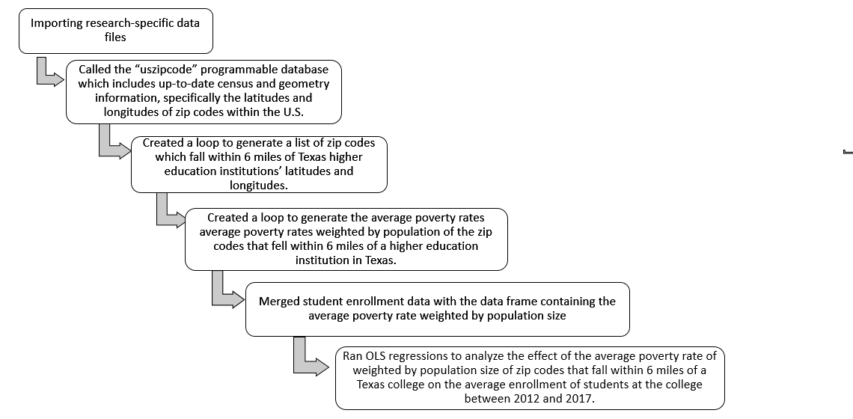*Research Life Cycle and Workflow*

1. Diaz, V. (2008). Relationships between District Size, Socioeconomics, Expenditures, and Student Achievement in Washington. *Rural Educator*, *29*(3), 30-39. Retrieved from <https://files.eric.ed.gov/fulltext/EJ869295.pdf>; Skiba, R., & Rausch, M. K. (2004). The Relationship between Achievement, Discipline, and Race: An Analysis of Factors Predicting ISTEP Scores. Children Left Behind Policy Briefs. Supplementary Analysis 2-D. *Center for Evaluation and Education Policy, Indiana University*. Retrieved from <https://files.eric.ed.gov/fulltext/ED488899.pdf>; and Lacour, M., & Tissington, L. D. (2011). The effects of poverty on academic achievement. *Educational Research and Reviews*, *6*(7), 522-527. Retrived from <https://sustainablefreedomlab.org/wp-content/uploads/2015/11/Effects-of-Poverty-on-Academic-Achievement.pdf>
2. Lacour, M., & Tissington, L. D. (2011). The effects of poverty on academic achievement. *Educational Research and Reviews*, *6*(7), 522-527. Retrived from <https://sustainablefreedomlab.org/wp-content/uploads/2015/11/Effects-of-Poverty-on-Academic-Achievement.pdf>
3. Sirin, S. R. (2005). Socioeconomic status and academic achievement: A meta-analytic review of research. Review of educational research, 75(3), 417-453. Retrieved from <https://journals.sagepub.com/doi/pdf/10.3102/00346543075003417>
4. Claro, S., Paunesku, D., & Dweck, C. S. (2016). Growth mindset tempers the effects of poverty on academic achievement. Proceedings of the National Academy of Sciences, 113(31), 8664-8668. Retrieved from <https://www.pnas.org/content/pnas/113/31/8664.full.pdf>
5. Breger, L. (2014). Poverty Effects on Student Achievement: A Look at Chicago Public Schools. Retrieved from <https://opensiuc.lib.siu.edu/cgi/viewcontent.cgi?article=1730&context=gs_rp>
6. Ibid.
7. Griffith, A. L. (2008). Determinants of grades, persistence and major choice for low-income and minority students. Retrieved from <https://digitalcommons.ilr.cornell.edu/cgi/viewcontent.cgi?article=1121&context=workingpapers>
8. Engle, J., & Tinto, V. (2008). Moving Beyond Access: College Success for Low-Income, First-Generation Students. Pell Institute for the Study of Opportunity in Higher Education. Retrieved from <https://files.eric.ed.gov/fulltext/ED504448.pdf>
9. Berkner, L., Cuccaro-Alamin, S., and McCormick, A. (1996). Descriptive Summary of 1989–90 Beginning Postsecondary Students: Five Years Later. Washington, DC: National Center for Education Statistics
10. Dahill-Brown, S. E., Witte, J. F., & Wolfe, B. (2016). Income and Access to Higher Education: Are High Quality Universities Becoming More or Less Elite? A Longitudinal Case Study of Admissions at UW-Madison. RSF: The Russell Sage Foundation Journal of the Social Sciences, 2(1), 69-89. Retrieved from <https://www.ncbi.nlm.nih.gov/pmc/articles/PMC6103778/pdf/nihms-983985.pdf>
11. Perna, L. W. (2015). Improving College Access and Completion for Low-Income and First-Generation Students: The Role of College Access and Success Programs. Retrieved from http://repository.upenn.edu/gse_pubs/301 and Baum, S., Ma, J., & Payea, K. (2013). Education Pays. Washington, DC: College Board.
12. Castleman, B., & Goodman, J. (2018). Intensive college counseling and the enrollment and persistence of low-income students. Education Finance and Policy, 13(1), 19-41. Retrieved from <https://scholar.harvard.edu/files/joshuagoodman/files/efp_published_version.pdf>
13. Hillman, N. W. (2016). Geography of college opportunity: The case of education deserts. American Educational Research Journal, 53(4), 987-1021. Retrieved from <https://journals.sagepub.com/doi/pdf/10.3102/0002831216653204>